Max Mueller, Jared Moore, Ben Nowacki

CSE 2102

# Use Case Diagram:

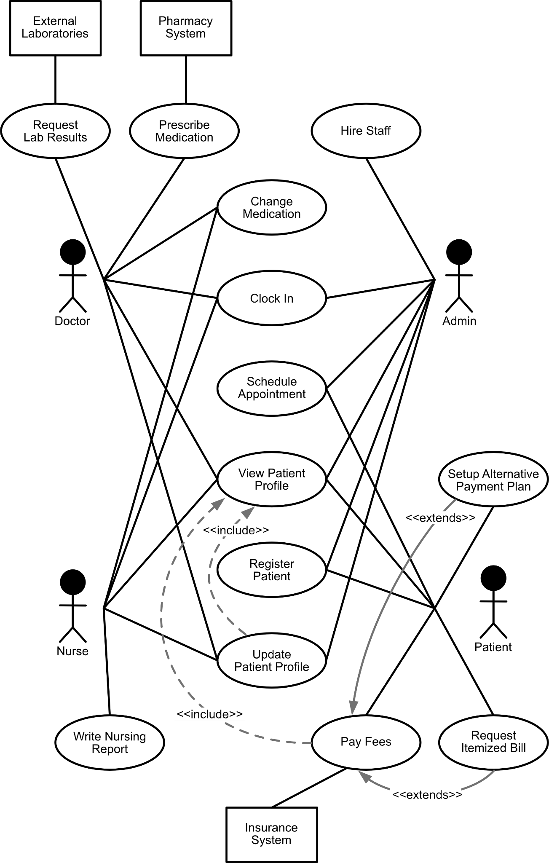

# Use Case Explanations:

**Prescribe Medication:**

Unique: Doctor (might be shared with nurses but in this case I think it should be unique)

Explanation: Doctors may want to prescribe new medicine to a patient they are currently seeing in order to meet their medical needs.

External System: The system might have to interact with a pharmacy system where the patients can get their prescriptions filled.

**Change Active Medication**:

Shared: Doctor, Nurse

Explanation: A running list of active medication is present on a patient's profile in order to assist doctors with diagnoses, this may change from appointment to appointment, so the nurse or doctor meeting with the patient may want to change this information to be updated on the patients profile.

Include: To change the patient’s active medication, the patient’s profile must first be checked.

**Write Nursing Report**

Unique: Nurse

Explanation: When doctors aren’t available, nurses are required to write a history of care and/or symptoms in a nursing report.

**View Patient Profile:**

Shared: Doctor, Nurse, Administrative Personnel

Explanation: A doctor or nurse would want to know the patient's prior health conditions before treating them. Administration would also need to know the patient’s information, such as mailing/billing address and previous/current appointments.

**Register Patient:**

Shared: Patient, Administrative Personnel

Explanation: A patient may want to register themselves to the system and set up their basic profile before coming in to receive any medical services. Administrative personnel may want to be able to register users in case someone comes into receive medical help without an account.

**Update Patient Info:**

Shared: Doctor, Nurse, Administrative Personnel

Explanation: A doctor or nurse may want to update the patient’s profile if their symptoms change. If the patient is moved to another room/department, administration would want to update the patient’s room location.

Include: Updating a patient’s info would include checking the patient’s profile first.

**Request Lab Results:**

Unique: Doctor

Explanation: A doctor may need tests done for a patient, in which lab results will need to be requested.

External System: The tests may need to be conducted through an external laboratory.

**Clock In:**

Shared: Administration Personnel, Doctor, Nurse

Explanation: Those employed by the hospital have specific requirements for timekeeping their own working hours that are not shared by the patient, but are shared by all workers of the hospital.

**Schedule Appointment:**

Shared: Patient, Administration Personnel

Explanation: A patient or staff may schedule a future appointment for follow up care.

**Hire Staff**:

Unique: Administrative Personnel

Explanation: Administrators may hire new staff to meet patient demand, expand the types of services the practice offers, and replace staff which was previously hired, but leaves for whatever reason.

**Pay Fees:**

Unique: Patient

Explanation: A patient will need to pay medical bills following an appointment/procedure.

External System: Paying fees will require accessing the insurance system.

Includes: Paying fees may include checking a patient’s profile to see services provided to the patient.

**Request Itemized Bill:**

Unique: Patient

Explanation: Patients have the ability to request itemized hospital bills to see a detailed list of services and supplies.

Extends: Requesting an itemized bill extends the use case “Pay Fees”. Paying fees is a base case in which requesting the itemized bill is an extension.

**Setup Alternative Payment Plan:**

Unique: Patient

Explanation: A patient may need to create a payment plan to pay fees.

Extends: Setting up a payment plan extends the base case of paying fees.